高可用架构为：
APP1：100.109.138.7
App2：100.109.138.33
Vip：100.109.138.34

脚本位置：/usr/local/src/check_proxy.sh
注：源备都用这个脚本；

A=`ps -C iaproxy --no-header |wc -l`
if [ $A -eq 0 ];then #如果proxy没有启动就启动proxy
# systemctl start i2proxy #重启proxy
if [ `ps -C iaproxy --no-header |wc -l` -eq 0 ];then #proxy重启失败，则停掉keepalived服务，进行VIP转移
killall keepalived
fi
fi
如图：
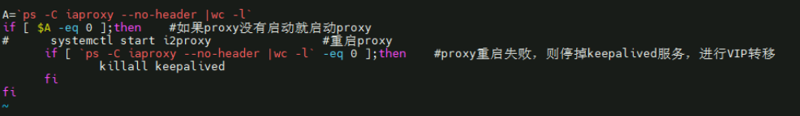

MASTER（主）配置：
路径为：vi /etc/keepalived/keepalived.conf
vrrp_script chk_proxy_port {
script "/usr/local/src/check_proxy.sh"
interval 2
weight 2
}

vrrp_instance VI_1 {
state MASTER
interface eth0
virtual_router_id 51
priority 100
advert_int 1
authentication {
auth_type PASS
auth_pass info
}
track_script {
chk_proxy_port
}

virtual_ipaddress {
100.109.138.34
}

}
如图：
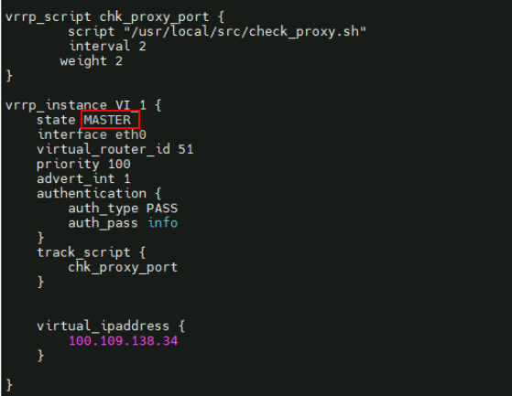

MASTER（主）配置：
路径为：vi /etc/keepalived/keepalived.conf
vrrp_script chk_proxy_port {
script "/usr/local/src/check_proxy.sh"
interval 2
weight 2

}

vrrp_instance VI_1 {
state BACKUP
interface eth0
virtual_router_id 51
priority 80
advert_int 1

authentication {
auth_type PASS
auth_pass info
}
track_script {
chk_proxy_port
}
virtual_ipaddress {
100.109.138.34
}

}

如图：
